Eventi
Use Case Specification

Submitted to:

Asst. Prof. Ma. Rowena C. Solamo
Faculty Member
Department of Computer Science
College of Engineering
University of the Philippines, Diliman

Submitted by:
Dimaano, Aaron Diego I.
Lopez, Matthew S.
Torres, Jacob Angelo V.

In partial fulfillment of academic requirements
for the course
CS 191 Software Engineering I
of the
1st Semester, AY 2015-2016
Unique Reference:
The documents are stored in https://github.com/Tom-2013-06417/CS191-192_Event_Sharing/tree/master/02-Requirements%20Engineering.
Link to this document: https://github.com/Tom-2013-06417/CS191-192_Event_Sharing/blob/master/02-Requirements%20Engineering/12.0%20-%20Submit%20feedback.pdf.

Document Purpose:
The purpose of this document is to exhaust the step-by-step process of the Use Cases in every scenario possible.

Target Audience:
To our project client and adviser, our fellow 191 classmates, and our future selves when they need to refer back to this document.

Revision Control:

Revision Date | Person Responsible | Version  Number | Modification
09/18/15 | Dimaano, Diego  Lopez, Matthew  Torres, Jacob | 1.0 | Initial Document

Use-Case Name: Submit feedback

Description: This feature catalyzes the improvement of the site. By allowing users to provide feedback, administrators can manage the information coursing through the site. This functionality also allows people to point out points for improvement, which include, but are not limited to, bugs, typos, and grammatical errors within the site.

Preconditions: There is an internet connection to the Eventi server and a device with browsing capabilities.

Flow of Events:

Scenario Name | Description
Scenario 1 (Basic Flow)  User reports wrong /  offensive content | 1. User identifies a concern regarding the site  2. User deems this as offensive content  3. User reports the content to the Administrators  4. System hides the content from being seen by the User  5. System confirms that the Administrators have received their concern
Scenario 2  User provides general feedback | 1. User identifies a concern regarding the site  2. User reports the concern to the Administrator  3. System confirms that the Administrators have received their complaint

Activity Diagram of the Flow of Events:

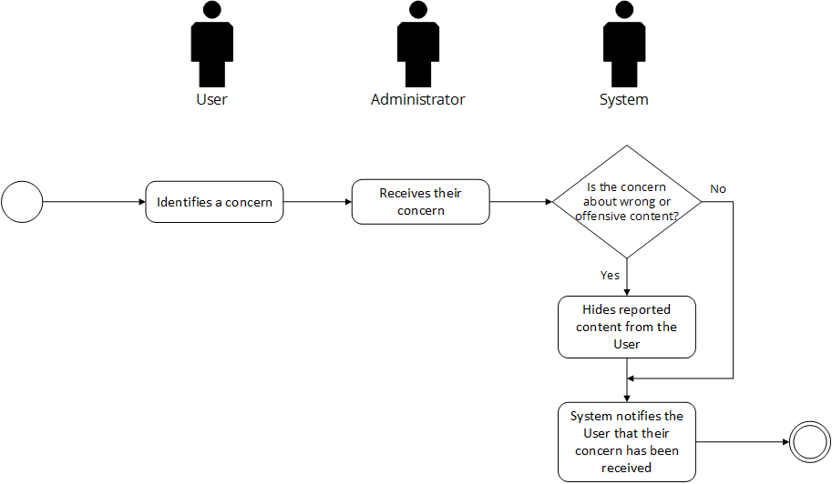

Post-conditions: Successful: The reports yielded satisfactory administrative judgement results.
Failed: The website did not load. The feedback failed to submit.

Special Requirements: NONE

